**On a Seneca lab PC**, launch Visual Studio Community **2017** from **MyApps**.See[**http://inside.senecacollege.ca/its/software/myapps/**](http://inside.senecacollege.ca/its/software/myapps/).It is usuallyavailable from a tab inside the Firefox browser.

On your own machine, you can install Visual Studio Community from <https://www.visualstudio.com/vs/community/>. It is a “fully-featured, extensible, free IDE for creating modern applications for Android, iOS, Windows, as well as web applications and cloud services.” The Visual Studio IDE that supports C and C++ languages **works only in a Windows environment**. Apple macOS users and Linux gurus must run a dual boot system (e.g. Apple [Bootcamp](https://support.apple.com/en-ca/boot-camp)) or run the VS IDE inside a virtual machine (e.g. [Parallels](http://inside.senecacollege.ca/its/software/hub/senecahup.html) for macOS). Get Windows from <sict.ca> and click on **Microsoft software for School of ICT students**. Installing Visual Studio Code or VS for macOS will just waste your time.

To start Visual Studio IDE from your own PC…  
Press the Windows key or click the Windows icon in the lower left of your screen and start typing “Visual Studio” until you see   
 (click on this or press Enter to launch)

**Show these notes on one side of your screen: Windows key + 🡪 [right arrow]**

**Show Visual Studio beside these notes with Windows key + 🡨 [left arrow]**

Because Visual Studio (VS) can manage various types of projects, it is one of the industry standards for systems development. As such, it is far more than just a programming code editor. Thus, the next few steps required your careful attention to set up the VS project for the type of program we will be creating.

**Create a new** [**project in Visual Studio**](https://msdn.microsoft.com/en-us/library/b142f8e7.aspx)**…**

* VS menu: select File | New | Project (Ctrl+Shift+N)  
  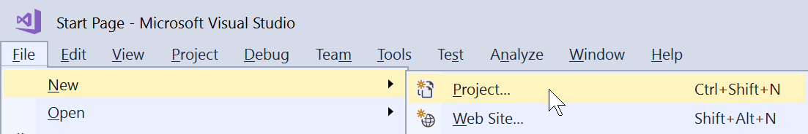
* In the New Project dialog, under Installed,
  + collapse Visual C# if it is expanded,
  + expand **Visual C++** and select **Windows Desktop**
  + in the center pane, select **Windows Desktop Wizard**   
    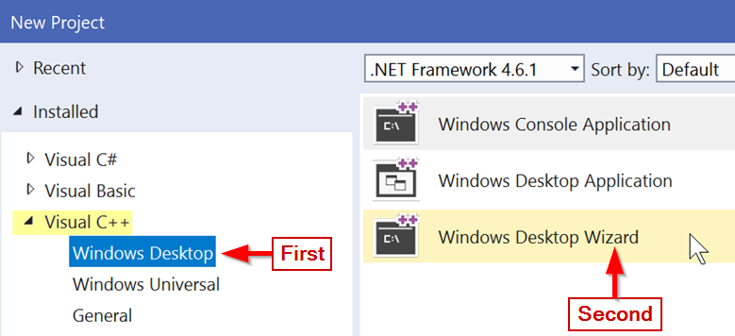
  + 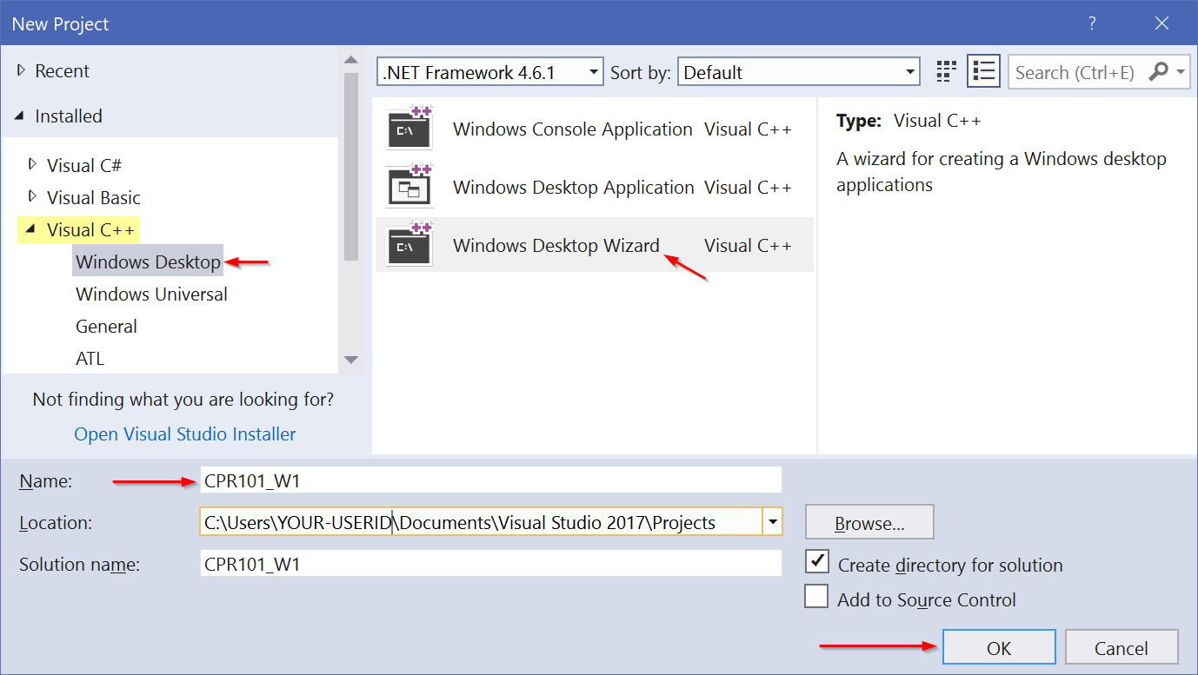Enter **CPR101_W1** as the Project Name | Select OK
  + Lastly, check Empty project, uncheck pre-compiled headers, press Enter  
    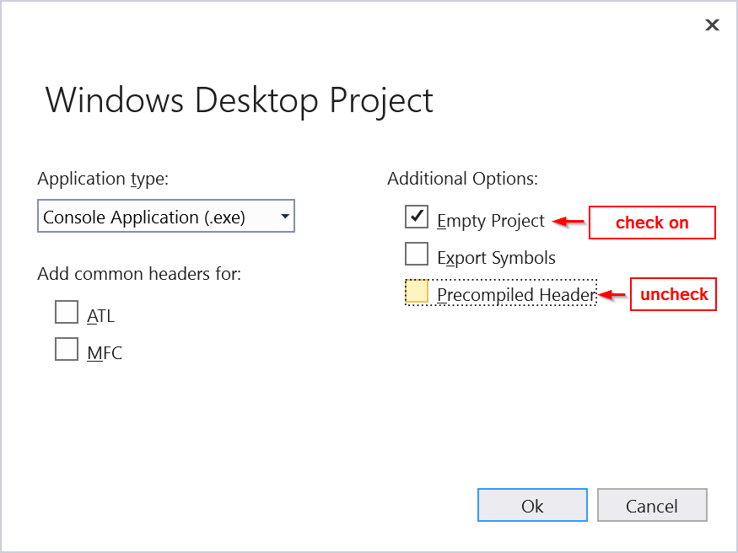

**Create a C language source code file…**

* VS menu: select Project | Add new Item (Ctrl+Shift+A)
* Under Installed / Visual C++
* ensure C++ File (.cpp) in the center pane is selected
* enter **helloWorld.c** as the File Name | press Add
  + ***Make sure the file extension is “.c”, not the default .cpp  
    This forces Visual Studio to use the C compiler instead of C++.***

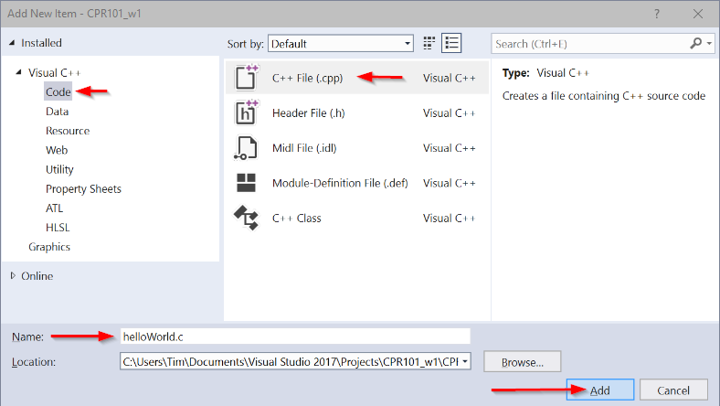

* Copy & paste the source code for the classic first program, “Hello World”.  
  Change yourNameHere to your own name.

/* Hello World is the traditional first program. It became legendary in 1978 when Kernighan and Ritchie published The C Programming Language. It is now the canonical minimal test message in the C/Unix universe. */

#include <stdio.h> // C language module providing Input/Output facilities

int main(void) // the system always calls main() to start a C program

{

printf("Hello, World!\n"); // output greeting

printf("This is yourNameHere.\n"); // output your name

return 0; // return to operating system

}

* Save the source file (Ctrl+S)

Compile your C program…

* VS menu: select **Build** | **Build Solution** (Ctrl+Shift+B)

The Output pane below your code should show   
1>----- Build started: Project: CPR101_w1, Configuration: Debug Win32 -----

1> helloworld.c

1> [output of executable and debug files]

========== Build: 1 succeeded, 0 failed, 0 up-to-date, 0 skipped ==========

If it did not succeed,

* fix your source code to match the above and then try Build Solution again.
* If your code *does* match the above, the problem is usually due to VS trying to compile your source file (and other sources files, if present) with different project or item options than the ones described earlier in the setup.
  + At this point, it is best to start again by creating a new Project using a different name. (You can reuse the original name but first you must find and delete the project under the “Projects” folder.)

When the compile was successful, run your program.

* VS menu: select **Debug | Start without Debugging** (Ctrl+F5)
* a terminal console window will open with   
  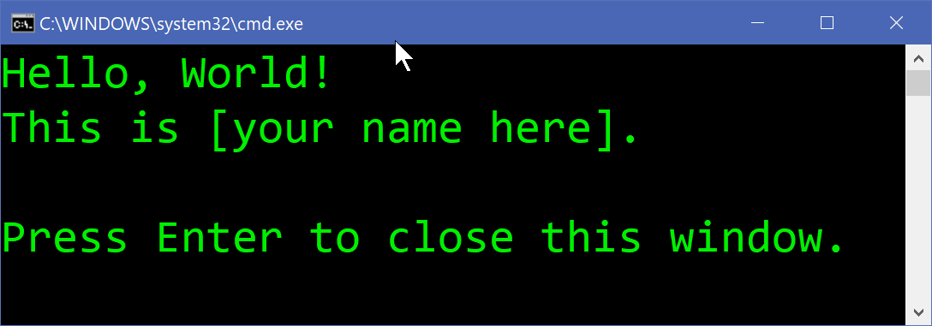
* close the window when you’ve sufficiently admired your work.

**Now, where is that** helloWorld.c **source file?**   
It is buried under the VS Project name folder.   
And where is that?  
There are a number of ways to find it.

You can use the File Explorer from the top of the folder structure down ( + E)

* File Explorer has a Search feature but if you search “This PC” for **file:helloWorld.c**, your patience will be tested.
* Windows usually stores your files under the Documents folder on your own machine or in the Desktop folder of Seneca lab PCs. Look under a folder name matching “Visual Studio 2015” and/or your VS Project name.

You can start from the file’s location and work your way up the folder structure:

* Press the Windows key and type the filename **helloWorld.c**
* Right clicking on the file name, depending on your PC’s configuration may give you a list of options including “Explore” or “Open File Location”

You can use VS:

* In the Solution Explorer pane, right click on the project name and select Open Folder in File Explorer
* Hover the mouse pointer over the **helloWorld.c** tab and the full path will appear.
* Right click on the **helloWorld.c** tab in the editing pane for more options.

**File Explorer**’s useful features: (Windows key + E)

* The left pane navigates the folder hierarchy
* The right pane shows files and folders in your current location

